Butte City Community Services District

PO Box 124

Butte City CA 95920

530-884-8448

ButteCityBoard@gmail.com

**To: Property Owner and/or Ratepayer**

**NOTICE OF PUBLIC HEARING REGARDING**

**PROPOSED ADJUSTMENTS TO WATER RATES**

**April 19 at 12:00 pm (noon)**

**at the Fire Station at**

**8262 Highway 162, Butte City, CA 95920**

**COMMUNITY OUTREACH MEETING**

The Butte City Community Services District (District) was established in 1964. The District provides water as well as parks and recreation services to the community of Butte City. The District’s water system relies on rates paid by customers to fund the costs of providing safe and clean drinking water to the community. The current water rate of $20.00 per month has been in place for many years and is well below the rates charged by other local utilities. Rate adjustments are needed to keep up with cost increases and keep the utility in good working condition. The Board of Directors will hold a public hearing on April 19, 2025 to consider water rate changes for the next five (5) years. You are receiving this notice because you are either a District utility customer or you own property receiving District water service.

***Why is a water rate change needed?***

An independent rate consultant reviewed the District’s total cost of providing water service and determined recommended rate adjustments. Current revenues of Butte City Community Services District include taxes (about $14,400) and water rate revenues (about $10,600) and miscellaneous fees of about $600. Current revenues total about $25,600.

These revenues are not covering the cost of providing service. Maintenance costs have increased significantly due to rising costs and the age of the system. In the last fiscal year, the District spent about $30,200 to provide clean and reliable water service to its customers with revenues received of only $25,600, the District operated at a deficit of about $4,600.

Capital improvement projects also need to be funded through rate increases. The District plans to construct security fencing around its wells at a cost of $8,000. In addition, the District must provide matching funds of $8,000 to receive a USDA grant. The USDA has offered the District a grant of about $24,000 to replace the pump, liner, electronics, and chlorination system of the park well. To receive the grant, the District must contribute $8,000 to this project. Improvements will modernize District facilities and reduce future maintenance costs. The USDA is also offering the District a $75,000 grant to replace its well and provide a storage tank in the next two (2) years. To receive this grant the District must contribute $25,000 to the project. The District does not have these funds available and is why it must raise its rates.

Rate increases are needed to overcome the operating deficit, to fund costly emergency repairs, to provide matching funds for grants, and to plan for the renewal of the water system.

***Proposed Monthly Water Rates***

Customers are billed monthly for water service. The proposed water rates are shown in the table below. If adopted by the Board of Directors, the maximum potential monthly rate would be $40 on July 1, 2025, to $45 on July 1, 2026, and to $50 on July 1, 2027. The proposed rates are the maximum rates the District can adopt during the five-year rate plan. The District may adopt rates at a lesser amount than the rates included in this notice, but not higher. Each year, the District will evaluate its revenues and expenses and determine appropriate rate increases up to the amounts shown below.

***Proposed Monthly Water Rates***

|  |  |  |  |  |  |  |
| --- | --- | --- | --- | --- | --- | --- |
|  | **Current** | **PROPOSED MONTHLY RATES** | | | | |
|  | **Monthly** | **Effective Date** | | | | |
|  | **Rate** | **July 1, 2025** | **July 1, 2026** | **July 1, 2027** | **July 1, 2028** | **July 1, 2029** |
|  |  |  |  |  |  |  |
| Water Rate per Dwelling Unit | $20.00 | $40.00 | $45.00 * | $50.00 * | $50.00 | $50.00 |
|  |  |  |  |  |  |  |

* Rate increase to $45.00 and $50.00 are not fixed. These are only a proposed increase that will be evaluated depending on increase operating costs.

The chart below compares Butte City’s current and proposed rates with the rates charged by other local communities. After the proposed rate increase, Butte City’s monthly water bill will remain in the lower-end of comparable water utility bills.

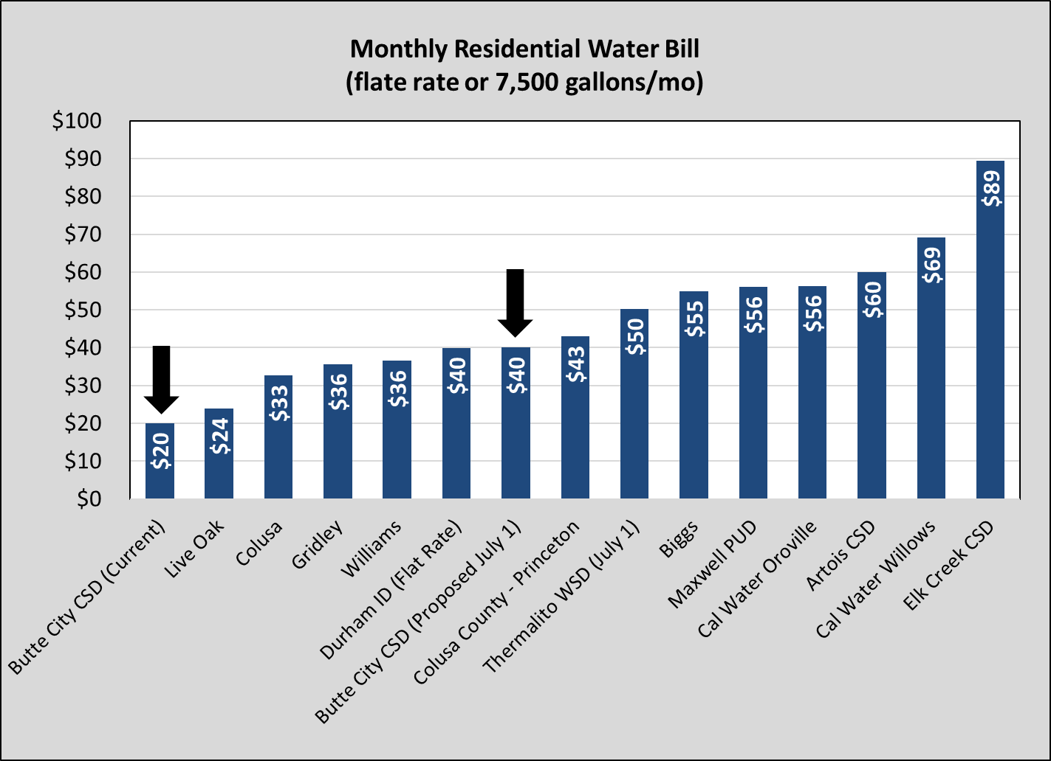

A public outreach meeting will be held on April 19, 2025 to review the District’s financial standing and proposed rate increase. District staff as well as the District’s independent rate consultant will be available to answer questions from the community.

***How do I file a protest or participate in the public hearing?***

The provisions of Proposition 218 provide that certain types of “Property Related Fees” such as water rates are subject to a “majority protest” process. Under the majority protest process, any property owner or customer of record may submit a written protest for the proposed increases; provided, however, **only one protest will be counted per identified property**. Only ratepayers or property owners may submit protests. A ratepayer is defined as the water service account holder. **PROTESTS WILL BE VALIDATED AT THE PUBLIC HEARING**. If protests are filed on behalf of a majority of the properties subject to the rates, the District cannot adopt the proposed rates.

***Every written protest MUST include ALL of the following to be counted:***

1. **A statement against the proposed water rates;**
2. **Name of the recorded owner or customer of record who is submitting the protest;**
3. **Identification of assessor’s parcel number or street address of the property with respect to which the protest is made (if you are submitting a protest on behalf of multiple properties, please list each property in your protest letter); and an**
4. **Original signature and legibly printed name of the record owner or customer of record who is submitting the protest.**

Protests must be submitted **in writing** by one of the three methods listed below:

1. Mail to - Prop 218 Protest, PO Box 124, Butte City CA 95920; or
2. In-person at the Public Hearing, prior to the conclusion of the Public Hearing; or
3. Emailed to ButteCityBoard@gmail.com; emailed protests must attach a scanned copy of the signature of the property owner or customer. Emailed protests must be received by 5 pm on May 30, 2025.

**Regardless of how the written protest is submitted, it must be received by the District prior to the conclusion of the public comment portion of the Public Hearing on May 31, 2025.** Postmark dates will not be accepted; please identify on the front of the envelope for any written protest, whether mailed or submitted in-person to the District, that the enclosed protest is for the Public Hearing on Water Rate Increases. Emailed protests must be received by 5:00 pm on May 30, 2025. Oral comments at the Public Hearing will not qualify as formal protests unless accompanied by a written protest.

The District will hold the board meeting on May 31, 2025 at 12:00 pm (noon). At the conclusion of the meeting, protests will be counted and validated. If protests are filed on behalf of a majority of the properties subject to the rates before the end of the meeting, the District cannot adopt the proposed rates. If a majority of the properties do not protest the proposed increase, the District has the authority to adopt the proposed water rates. The first-rate change, if enacted, will go into effect on or after July 1, 2025.

**Pursuant to California Government Code 53759, a 120-day statute of limitations applies to any legal challenge to a new, increased, or extended fee. All written objections must be submitted before the end of the public hearing as stated above and a failure to timely object in writing bars any right to challenge that fee or assessment through a legal proceeding.**